La bataille navale des syllabes

 | ou | on | an | in | au | ai | oi |  |  | ou | on | an | in | au | ai | oi
p | ……………… | ……………… | ……………… | ……………… | ……………… | ……………… | ……………… |  | p | ……………… | ……………… | ……………… | ……………… | ……………… | ……………… | ………………
b | ……………… | ……………… | ……………… | ……………… | ……………… | ……………… | ……………… |  | b | ……………… | ……………… | ……………… | ……………… | ……………… | ……………… | ………………
d | ……………… | ……………… | ……………… | ……………… | ……………… | ……………… | ……………… |  | d | ……………… | ……………… | ……………… | ……………… | ……………… | ……………… | ………………
t | ……………… | ……………… | ……………… | ……………… | ……………… | ……………… | ……………… |  | t | ……………… | ……………… | ……………… | ……………… | ……………… | ……………… | ………………
f | ……………… | ……………… | ……………… | ……………… | ……………… | ……………… | ……………… |  | f | ……………… | ……………… | ……………… | ……………… | ……………… | ……………… | ………………
ch | ……………… | ……………… | ……………… | ……………… | ……………… | ……………… | ……………… |  | ch | ……………… | ……………… | ……………… | ……………… | ……………… | ……………… | ………………
m | ……………… | ……………… | ……………… | ……………… | ……………… | ……………… | ……………… |  | m | ……………… | ……………… | ……………… | ……………… | ……………… | ……………… | ………………
n | ……………… | ……………… | ……………… | ……………… | ……………… | ……………… | ……………… |  | n | ……………… | ……………… | ……………… | ……………… | ……………… | ……………… | ………………

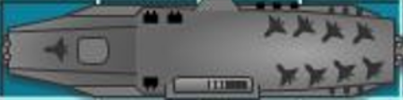 | 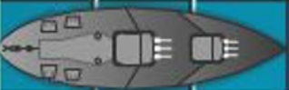 | 


